Experiment No. 1
Experiment Name:
DDL Commands – CREATE, ALTER, DROP

Aim:
To create, alter, drop, rename, and truncate database objects using Data Definition Language (DDL) statements in MySQL.

Procedure:
- Open MySQL Workbench and connect to the local MySQL server instance using the root credentials.
- Create a new database using the CREATE DATABASE command and select it using the USE command.
- Create the required tables (STUDENT, FACULTY, DEPARTMENT, COURSE) using the CREATE TABLE command, specifying appropriate column names and data types as per the given structure.
- Verify the structure of each created table using the DESC (DESCRIBE) command.
- Modify the structure of an existing table (add a new column) using the ALTER TABLE ... ADD command.
- Verify the modification by describing the altered table again.
- Execute the queries in the SQL Editor and observe the output in the Result Grid/Output panel.
- Record the output/screenshots for each step as proof of successful execution.

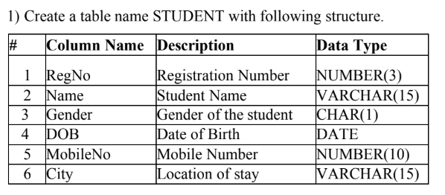
OUTPUT:
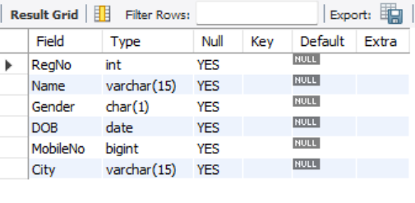
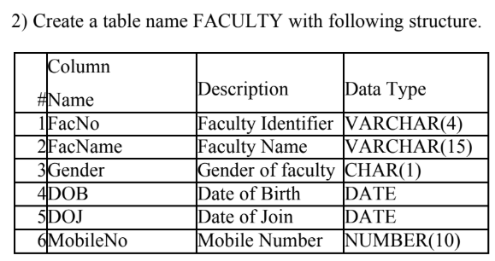
OUTPUT:
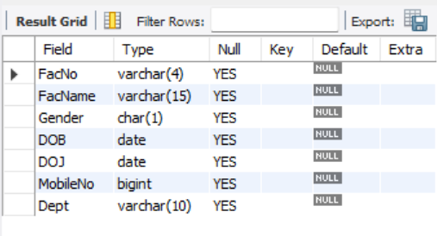
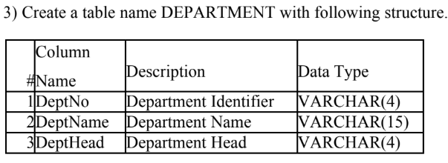
OUTPUT:
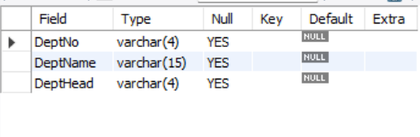
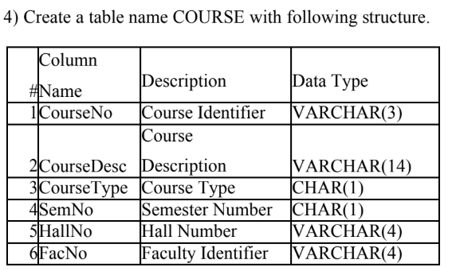
OUTPUT:
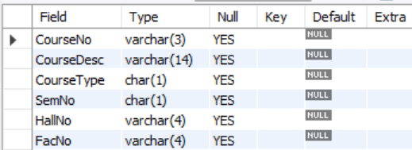

5) Modify the table FACULTY by adding a column name Dept of datatype VARCHAR.
OUTPUT:
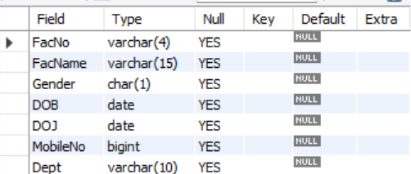

Result:
Tables STUDENT, FACULTY, DEPARTMENT, and COURSE were successfully created, and the FACULTY table was successfully altered to include an additional Dept column, using DDL commands in MySQL Workbench. All commands were executed successfully as verified through the DESC command output.

